Tenzin Norden

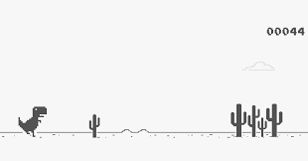

From what I found the game is also called T-Rex Runner, so I think its safe to assume that the dinosaur in this is a Tyrannosaurus Rex which belongs to the Theropods because the dinosaur has three toes. This is known to be a Theropod foot. T-rex belongs to the infraorder Coelurosauria and the family Tyrannosauridae. It had large hindlimbs, small forelimbs, small eyes, and a giant head. The reconstruction isn’t very accurate as it’s a 2d sprite, but the proportions of the body, legs and head seems to match that of a T-Rex. Like the real-life counterpart, its tail seems a bit on the shorter side, but the width of its tail seems appropriate to the rest of its body. In one of the lectures, they talked about the way T-Rexes might have sounded and that instead of opening their entire mouth and roaring they might have used low-pitched frequency sounds to communicate across large vistas, and to strike fear into the prey. In this representation the dinosaur seems to have its mouth open, which is another reason why it’s not exactly accurate. Unfortunately, the dinosaur doesn’t make a sound in this game so I can’t say whether it is accurate in that way or not. I would like to see a 3d version of the T-Rex with sharp teeth and better proportions. The dinosaur being a carnivore, I would have liked to see some sort of animal running away from it. But while it lacks detail in its simplicity it conveys that it is a T-rex. From this reconstruction we can see that the dinosaur had extraordinarily strong hind limbs which allowed the dinosaur to move and fast speed despite its enormous size and weight. But while the T-rex might have been able to run like this reconstruction in real life it didn’t jump as high as its height in vertical jumps.

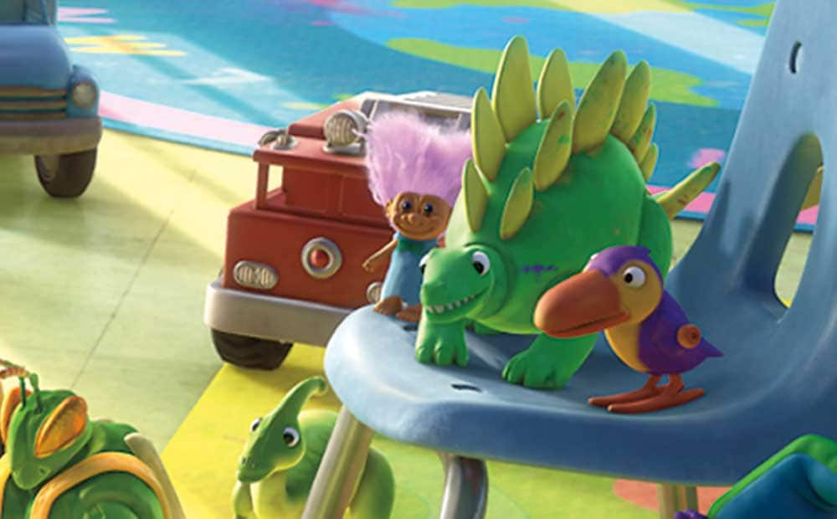

This dinosaur makes a cameo in the movie Toy Story 3 a hit Pixar movie that came out in 2010. I think this dinosaur is a stegosaurus meaning “roofed lizard” belonging to the thyreophorans which fall under the armored dinosaurs. The infraorder is Stegosauria. The stegosaurus is a quadrupedal dinosaur with kite shaped plates running across the back of its spine. I think this dinosaur belongs in this fauna because of its armor plates. The dinosaur has spiked at the end of its tail which seems to be missing in the reconstruction, but it does seem to have a long tail. If looking at the body proportions, the reconstruction is fairly accurate. The toy similar to the dinosaur has small forelimbs and long hind limbs, we can notice this as its joints at the back seem to be higher than the front joints. It has a small head compared to its body which is accurate. The reconstruction seems to be missing the smaller armor pieces at the back of a stegosaurus neck. The real dinosaur unlike its reconstructed toy seems to have an almost beak like mouth. While we don’t the know the exact color that the stegosaurus boasted, its doubtful that they had bright green skin and yellow armor this too I believe falls under inaccurate reconstruction. This herbivore ate plants low to the ground, thus the position of the head closer to the ground. There isn’t much wrong with the representation, it can be identified as a stegosaurus. But I would have liked a tail with spikes and a more beak like mouth this would greatly improve the reconstruction in my opinion. There was one lecture which showed how they could have flushed their armor plates with color to intimidate the predators, if true that would also be a great addition to make this representation even better.